Create, Modify, and Remove Files and Folders in Linux

Head's up: You'll experience a delay as the labs initially load, particularly for Windows labs.

**Introduction**

Today, Linux is everywhere. Lots of the server systems behind your favorite websites are Linux-based. As an IT Support Specialist, you’ll most likely be interacting with Linux on a regular basis, mainly through the command line. Actions like modifying configuration files and moving or copying them may become part of your everyday tasks. File management in Linux is a super important core skill to have as an IT Support Specialist. So, let’s dive in!

**What you’ll do**

You’ll learn how to navigate a Linux file system from the command line and understand the basics of creating, modifying, copying, and deleting files and directories. Your main learning objective for this lab is to practice these commands in the Linux VM.

**You will have 60 minutes to complete this lab.**

# **Create, Modify and Remove Files and Folders in Linux**

External IP address



content\_copy

username



content\_copy

[file\_download](https://googlecoursera.qwiklabs.com/lab_instances/download_pem/15701398" \t "_blank)

[Download PEM](https://googlecoursera.qwiklabs.com/lab_instances/download_pem/15701398" \t "_blank)

[file\_download](https://googlecoursera.qwiklabs.com/lab_instances/download_ppk/15701398" \t "_blank)

[Download PPK](https://googlecoursera.qwiklabs.com/lab_instances/download_ppk/15701398" \t "_blank)

## Introduction

Today, Linux is everywhere. Lots of the server systems behind your favorite websites are Linux-based. As an IT Support Specialist, you'll most likely be interacting with Linux on a regular basis, mainly through the command line. Actions like modifying configuration files and moving or copying them may become part of your everyday tasks. File management in Linux is a super important core skill to have as an IT Support Specialist. So, let's dive in!

**Head's up**: You'll experience a delay as the labs initially load (particularly for Windows labs). So, please **wait a couple of minutes for the labs to load**. Please also make sure to access the labs **directly through Coursera** and not in the Qwiklabs catalog. If you access the labs through the Qwiklabs catalog, you will not receive a grade. (As you know, a passing grade is required to matriculate through the course.) The grade is calculated when the lab is complete, so be sure to hit "**End Lab**" when you're done!

You'll have 60 minutes to complete this lab.

**What you'll do**

You'll learn how to navigate a Linux file system from the command line and understand the basics of creating, modifying, copying, and deleting files and directories. Your main learning objective for this lab is to practice these commands in the Linux VM.

**Learning tip**

We encourage you to try and memorize all of these commands as best you can. With enough practice, using Linux commands will become second nature to you. If you have access to your own Linux machine, try out the commands as you follow along in the next section.

If you don't have Linux available on your local machine, no worries! You can type these commands in a text editor, so you can refer back to them when you're doing the active lab exercises.

**Linux overview**

Before we kick things off, below is a brief intro into the Linux file system.

The **file system** controls how data is stored and retrieved in a computer. All files and folders in a Linux system are part of a bigger tree-like structure rooted at /. Files and folders are added to the file system by appending them to this tree structure, and deleted by removing them. **All file names are case sensitive**. When working with files and directories on the command line, special characters, like space and brackets, have to be **escaped** using a backslash.

**Note**: This section consists of basic commands to help you explore the Linux file system. Do not expect any interesting response back within this section, but they would be helpful in various stages of the lab.

Here are a few helpful navigation commands to help you explore the Linux file system:

You can check out the contents of the current directory using the ls command.

ls



You can view more details about the files, like ownership and permissions, by adding the flag -l to the ls command.

ls -l

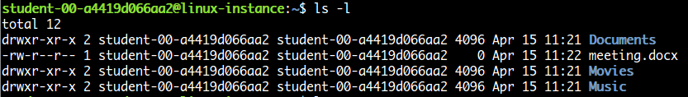

You can see hidden files in the current directory by passing flag a to the ls command.

ls -a



You can find out where you are in relation to the rest of the file system using the pwd command.

pwd



You can navigate to different directories using the cd command.

cd /path/to/other/directory



You can check out the contents of a file using the cat command.

cat /path/to/file/file\_name

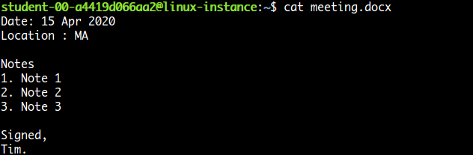

For large input files, the less commands allows movement within the files. The syntax is similar to that of the cat command, but you can move.

Reading large file using less

less /path/to/file/file\_name

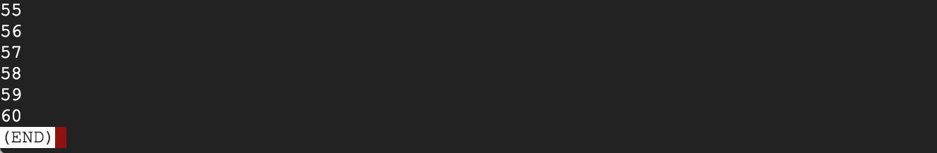

The command will provide you with a scrollable view of the content within the file, up to the end of the file content. Scroll down using "Enter", and exit the view by pressing "q".

The rest of this lab will teach you how to create, copy, modify, and remove files and folders.

### Start the lab

You'll need to start the lab before you can access the materials in the virtual machine OS. To do this, click the green “Start Lab” button at the top of the screen.

**Note:** For this lab you are going to access the **Linux VM** through your **local SSH Client**, and not use the **Google Console** (**Open GCP Console** button is not available for this lab).

Start Lab

After you click the “Start Lab” button, you will see all the SSH connection details on the left-hand side of your screen. You should have a screen that looks like this:

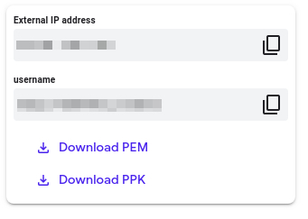

## Accessing the virtual machine

Please find one of the three relevant options below based on your device's operating system.

**Note:** Working with Qwiklabs may be similar to the work you'd perform as an **IT Support Specialist**; you'll be interfacing with a cutting-edge technology that requires multiple steps to access, and perhaps healthy doses of patience and persistence(!). You'll also be using **SSH** to enter the labs -- a critical skill in IT Support that you’ll be able to practice through the labs.

### Option 1: Windows Users: Connecting to your VM

In this section, you will use the PuTTY Secure Shell (SSH) client and your VM’s External IP address to connect.

**Download your PPK key file**

You can download the VM’s private key file in the PuTTY-compatible **PPK** format from the Qwiklabs Start Lab page. Click on **Download PPK**.

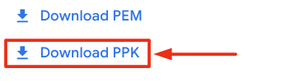

**Connect to your VM using SSH and PuTTY**

1. You can download Putty from [here](https://the.earth.li/~sgtatham/putty/latest/w64/putty.exe)
2. In the **Host Name (or IP address)** box, enter username@external\_ip\_address.

**Note:** Replace **username** and **external\_ip\_address** with values provided in the lab.



1. In the **Category** list, expand **SSH**.
2. Click **Auth** (don’t expand it).
3. In the **Private key file for authentication** box, browse to the PPK file that you downloaded and double-click it.
4. Click on the **Open** button.

**Note:** PPK file is to be imported into PuTTY tool using the Browse option available in it. It should not be opened directly but only to be used in PuTTY.



1. Click **Yes** when prompted to allow a first connection to this remote SSH server. Because you are using a key pair for authentication, you will not be prompted for a password.

**Common issues**

If PuTTY fails to connect to your Linux VM, verify that:

* You entered **<username>**@**<external ip address>** in PuTTY.
* You downloaded the fresh new PPK file for this lab from Qwiklabs.
* You are using the downloaded PPK file in PuTTY.

### Option 2: OSX and Linux users: Connecting to your VM via SSH

**Download your VM’s private key file.**

You can download the private key file in PEM format from the Qwiklabs Start Lab page. Click on **Download PEM**.

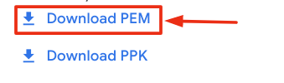

**Connect to the VM using the local Terminal application**

A **terminal** is a program which provides a **text-based interface for typing commands**. Here you will use your terminal as an SSH client to connect with lab provided Linux VM.

1. Open the Terminal application.
   * To open the terminal in Linux use the shortcut key **Ctrl+Alt+t**.
   * To open terminal in **Mac** (OSX) enter **cmd + space** and search for **terminal**.
2. Enter the following commands.

**Note:** Substitute the **path/filename for the PEM** file you downloaded, **username** and **External IP Address**.

You will most likely find the PEM file in **Downloads**. If you have not changed the download settings of your system, then the path of the PEM key will be **~/Downloads/qwikLABS-XXXXX.pem**

chmod 600 ~/Downloads/qwikLABS-XXXXX.pem

ssh -i ~/Downloads/qwikLABS-XXXXX.pem username@External Ip Address

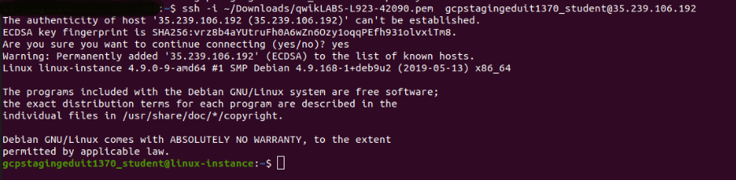

### Option 3: Chrome OS users: Connecting to your VM via SSH

**Note:** Make sure you are not in **Incognito/Private mode** while launching the application.

**Download your VM’s private key file.**

You can download the private key file in PEM format from the Qwiklabs Start Lab page. Click on **Download PEM**.



**Connect to your VM**

1. Add Secure Shell from [here](https://chrome.google.com/webstore/detail/secure-shell-app/pnhechapfaindjhompbnflcldabbghjo) to your Chrome browser.
2. Open the Secure Shell app and click on **[New Connection]**.

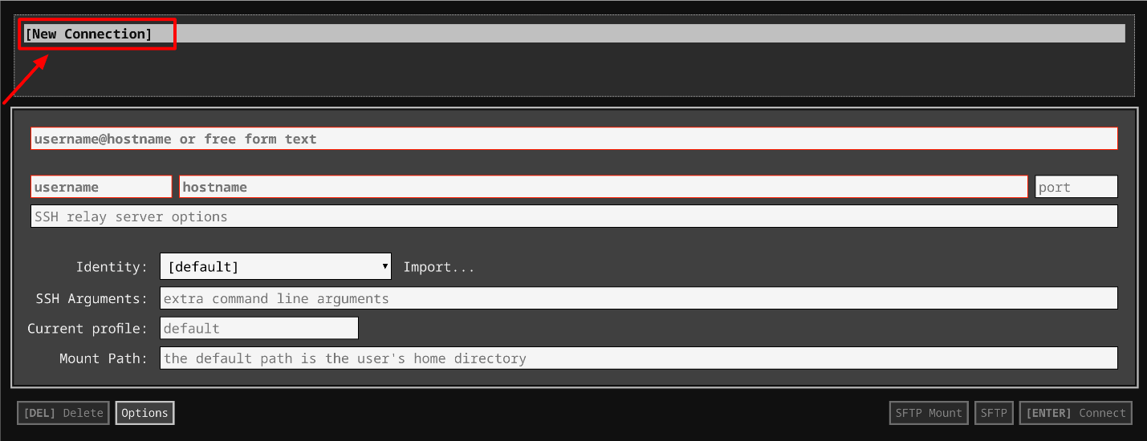

1. In the **username** section, enter the username given in the Connection Details Panel of the lab. And for the **hostname** section, enter the external IP of your VM instance that is mentioned in the Connection Details Panel of the lab.

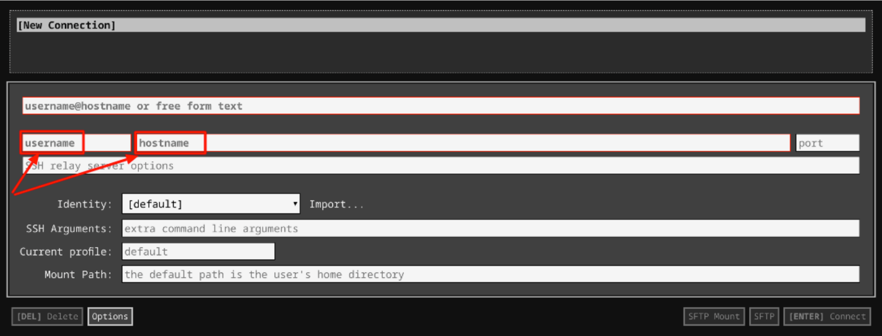

1. In the **Identity** section, import the downloaded PEM key by clicking on the **Import…** button beside the field. Choose your PEM key and click on the **OPEN** button.

**Note:** If the key is still not available after importing it, refresh the application, and select it from the **Identity** drop-down menu.

1. Once your key is uploaded, click on the **[ENTER] Connect** button below.

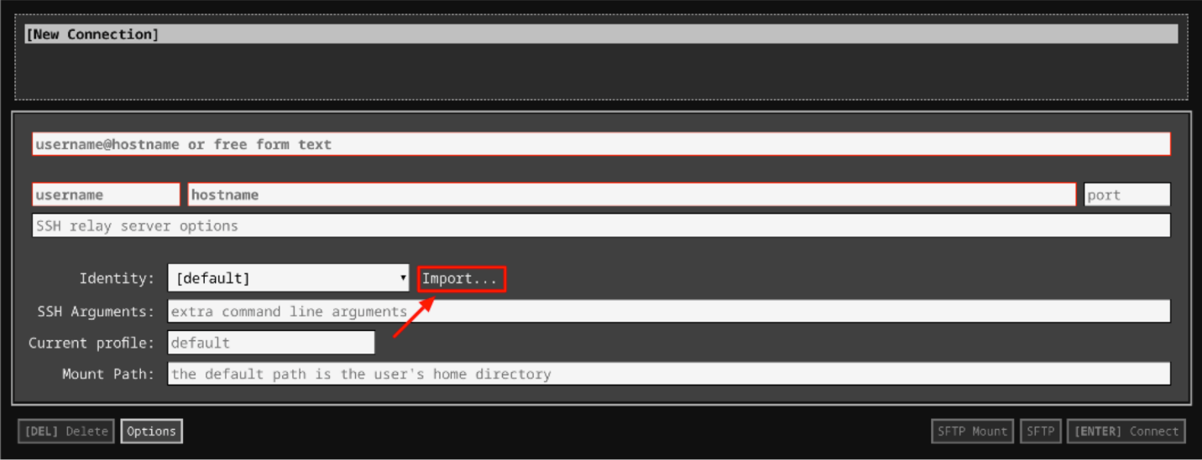

1. For any prompts, type **yes** to continue.
2. You have now successfully connected to your Linux VM.

You're now ready to continue with the lab!

## Creating directories (folders)

Directories (folders) in Linux are created using the mkdir command. The command takes the directory name as the argument.

**Note**: The example commands are for reference only.

**Example 1**

mkdir dir\_name

Multiple directories can be supplied as arguments, and mkdir will create all of them.

**Example 2**

mkdir dir1 dir2 dir3

**Parameters**

mkdir can take three options:

* -p: allow mkdir to create parent directories if they don't exist
* -m: (mode) used to set permissions of directories during creation
* -v: run command in verbose mode

Let's take a look at how to use mkdir by going through an example.

In this Linux virtual machine, directory /home/user/Desktop contains a file called "colors". We'll open the file, and for every line listed in it, we'll create a new folder with that name in the directory /home/user/Documents

Step 1: Change into working directory.

cd /home/user/Documents



Step 2: Show the contents of the file "colors" within the "Desktop" directory.

cat /home/user/Desktop/colors

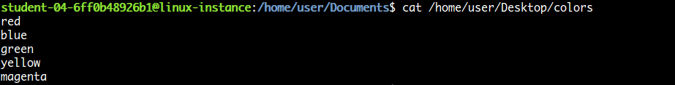

Step 3: Create the directories.

mkdir red blue green yellow magenta



Click Check my progress to verify the objective.

Create directories

Check my progress

**Removing empty directories**

To remove empty directories, use the rmdir command. The name of the directory to be removed is passed as an argument.

**Note**: The example commands are for reference only.

**Example 1**

rmdir dir\_name



Multiple directory names can be passed as arguments, and rmdir will remove all of them.

**Example 2**

rmdir dir1 dir2 dir3 dir4



**Head's up:** rmdir only removes empty directories. To remove a non-empty directory, the command rm, discussed later in this course, is used.

**Options**

rmdir takes only one option, which tells it to remove parent directories if they're also empty.

* -p: remove parent directories, if they're also empty

**Creating files**

By default, the touch command is used to change the modification and access times of a file. If the file doesn't exist, the touch command is used to create a file with default permissions.

Let's take a look at an example of how to use the touch command. In the current directory, we can create an empty file called "empty\_file":

touch empty\_file



The touch command can take the c option to prevent a new file from being created.

**Options**

* -c: do not create file if it doesn't exist

## Copying, moving and deleting files and directories (folders)

cp

The cp command is used to make a copy of one or more directories or files. The command takes **at least** one source name and one target name. If the target is a file, then the source must also be a file. A copy of the source will be made with the new name supplied in target. If the target name isn't specified, a copy of source will be made in the target directory under the same name. If a file with the target name already exists in the target directory, it'll be replaced. If the target is an existing directory, then all sources (one or more) will be copied into the target directory. If the target is a directory that doesn't exist, then the source must also be a directory. A copy of the directory and its contents will be made in target under the same name.

**Note**: The example commands are for reference only.

**Example 1**

Copy the file "source\_file" in the directory /home/user/ to the directory "duplicates" as "target\_file".

cp /home/user/source\_file /home/user/duplicates/target\_file



The duplicates directory now contains a copy of the original file.

mv

The move command is used to move one or more files or directories into a different location, or rename them to a new name. You're required to pass **at least** one source and target file names or directories. The mv command follows the rules for existing or non-existing directories or files, as does cp.

**Example 2**

Move the file "source\_file" in /home/user/ to the directory "moved\_files" and give it the name "target\_name".

mv /home/user/source\_file /home/user/moved\_files/target\_file



The original directory doesn't contain the file now. It's been moved to the new directory "moved\_files".

rm

The rm command is used to remove one or more files. You need to supply **at least** one argument to remove.

**Example 3**

We can remove the duplicate file we created in the directory "duplicates" using rm

rm /home/user/duplicates/target\_file



Let's see how to copy, move, and rename files by going through a few examples.

In the directory /home/user/Pictures, we'll take all the hidden files and move them into the directory /home/user/Documents/Hidden

Step 1: Change into the Pictures directory.

cd /home/user/Pictures



Step 2: Show the directory contents, including hidden files.

ls -a



Step 3: Move the hidden files into the target directory.

mv .apple .banana .broccoli .milk /home/user/Documents/Hidden



Click Check my progress to verify the objective.

Move hidden files

Check my progress

In the directory /home/user/Movies, there's a folder called "Europe Pictures". We'll move this folder into the correct directory for pictures: /home/user/Pictures. Note the use of the backslash "\" to escape the space between "Europe" and "Pictures" in the directory name, "Europe Pictures".

mv /home/user/Movies/Europe\ Pictures /home/user/Pictures



You can also use a "dot" to copy or move files to the current directory. In the directory /home/user/Images, we can move the file "Vacation.JPG" into the Pictures directory. To do that, we change into the Pictures directory, then add a "dot" to the mv command as the target.

cd /home/user/Pictures

mv /home/user/Images/Vacation.JPG .

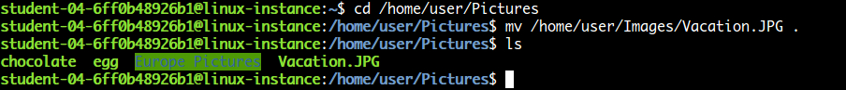

Click Check my progress to verify the objective.

Move files and folders

Check my progress

Some files in the directory /home/user/Music need to be cleaned up. We'll see an example of removing files and directories by removing-:

* Best\_of\_the\_90s
* 80s\_jams
* Classical
* Rock (folder)

Step 1: Navigate to the Music folder.

cd /home/user/Music

Step 2: Remove files.

rm Best\_of\_the\_90s 80s\_jams Classical

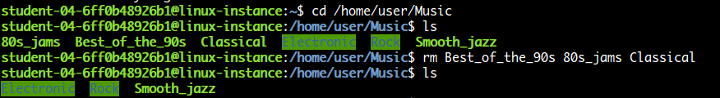

Step 3: Remove the directory.

rmdir Rock



To remove a directory with content, the rm command is used instead of rmdir. The option -r tells the command to remove the directory, along with its content recursively.

Click Check my progress to verify the objective.

Remove files and folders

Check my progress

**Note**: The example commands are for reference only.

**Example 4**

rm -r non\_empty\_dir

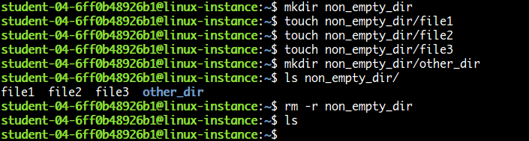

## Searching in files

grep

grep is a super powerful Linux command used to search through files for the occurrence of a string of characters that matches a specified pattern. We can use the command in combination with a bunch of different options and flags for efficient searching.

**Options and flags**

* -r: search recursively
* -w: match the whole word
* -n: only in line number
* -e: match pattern
* --include and --exclude: include and exclude files in the search
* --include-dir and --exclude-dir: include or exclude directories in the search

Let's take a look at the grep command in action. In the directory /home/user/Downloads of your virtual machine, a number of files exist. We'll find the files that have the word "vacation" in them, and move them to /home/user/Documents

Step 1: Find files.

grep -rw /home/user/Downloads -e "vacation"



Step 2: Move the directories that match into the target directory.

mv /home/user/Downloads/Iceland /home/user/Downloads/Japan /home/user/Documents



Click Check my progress to verify the objective.

Search the files and move them

Check my progress

**Editing files**

Lots of Linux distributions come with pre-installed text editors. The most popular ones are vi and nano, which will be included in nearly every distribution. Other text editors, like Emacs and Gedit, might also be present. In this lab, we'll modify files using the Nano editor.

You can use the nano command to open the Nano editor and modify an existing file, or create a new one. To edit an existing file, we'll first start with opening it.

**Note**: The example commands are for reference only.

**Example:**

nano /path/to/existing/file

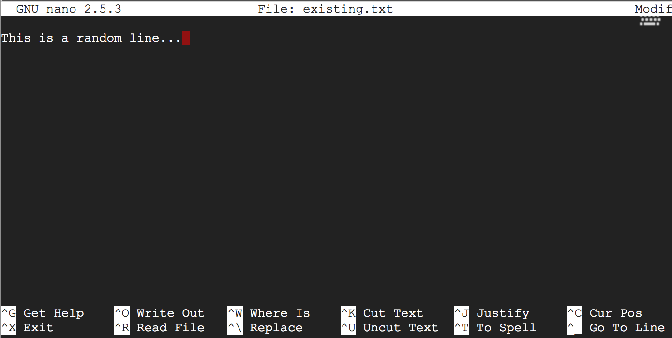

The command will open the file in the terminal and display the current file contents. To modify, you can edit the content in the terminal, just like a normal editor. The editor is managed using various shortcuts.

To save modifications to the file, use Ctrl+O-:

CTRL-O

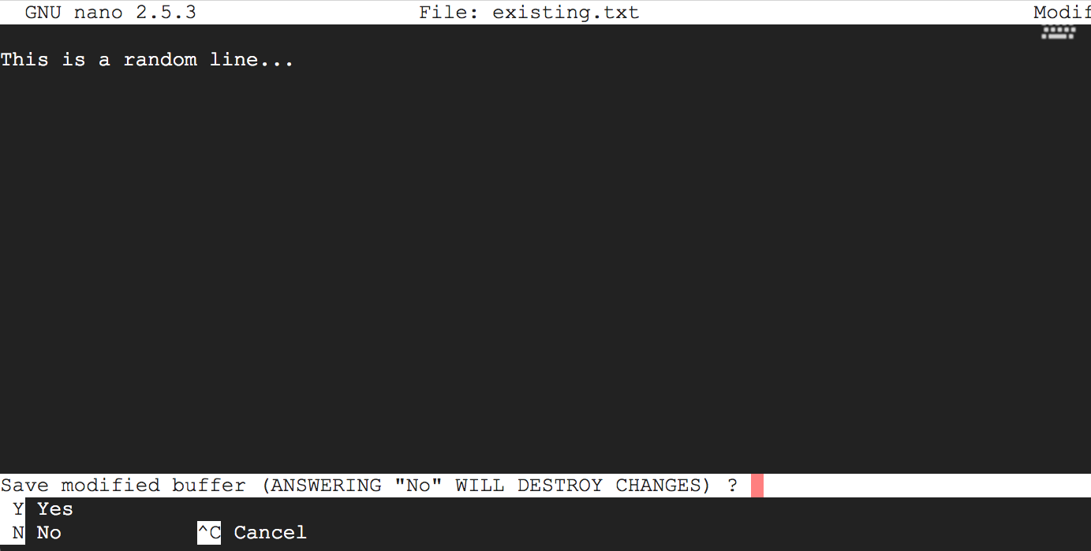

Once editing is done, we can close and exit the program using Ctrl+X

CTRL-X

**NB:** At any point in using the editor, you can get help using Ctrl+G

CTRL-G

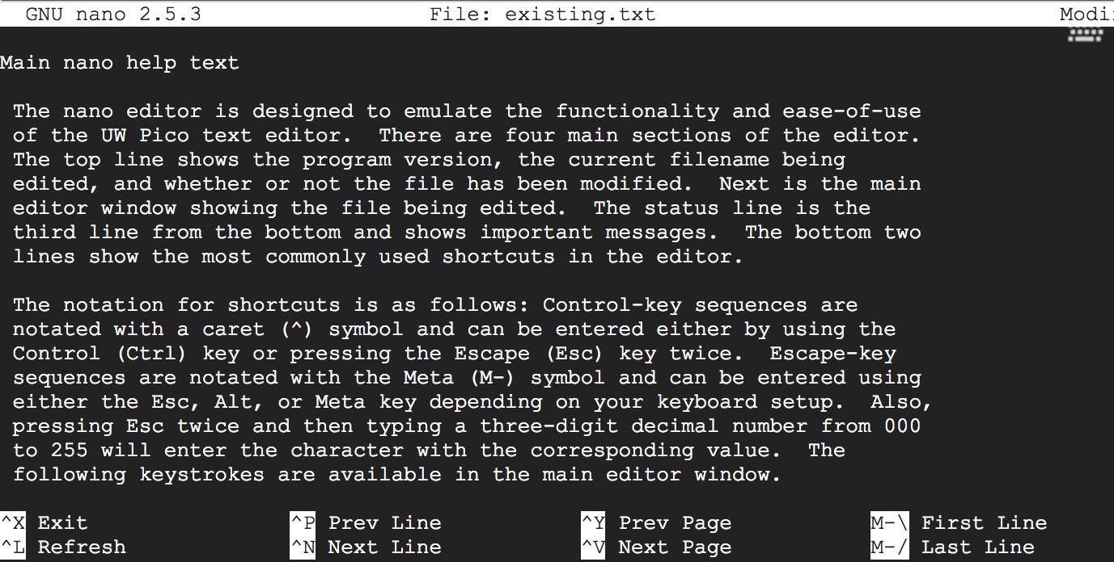

To exit help mode, use Ctrl+X

CTRL-X

Alright, now let's practice how to edit files using nano.

In the current directory, create an empty file called editor\_test.txt

touch editor\_test.txt



Open the file with the Nano editor.

nano editor\_test.txt

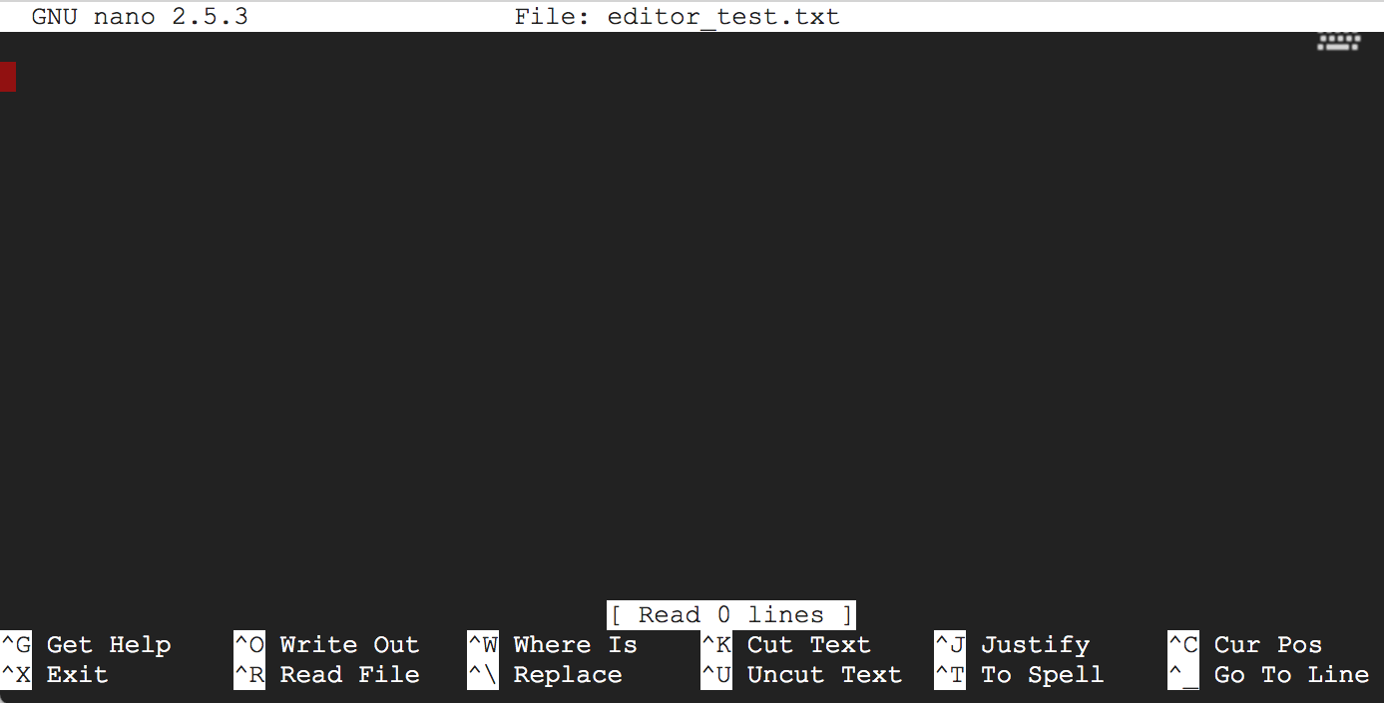

Add content to the file. (In this case, we add five lines, each separated by an empty line.)

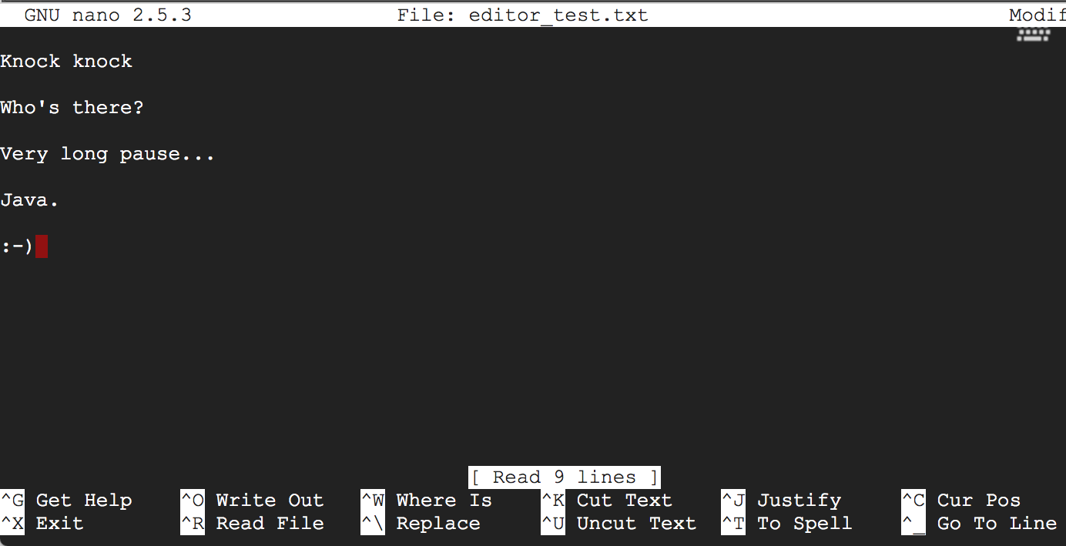

Save the file by hitting Ctrl+O

CTRL-O

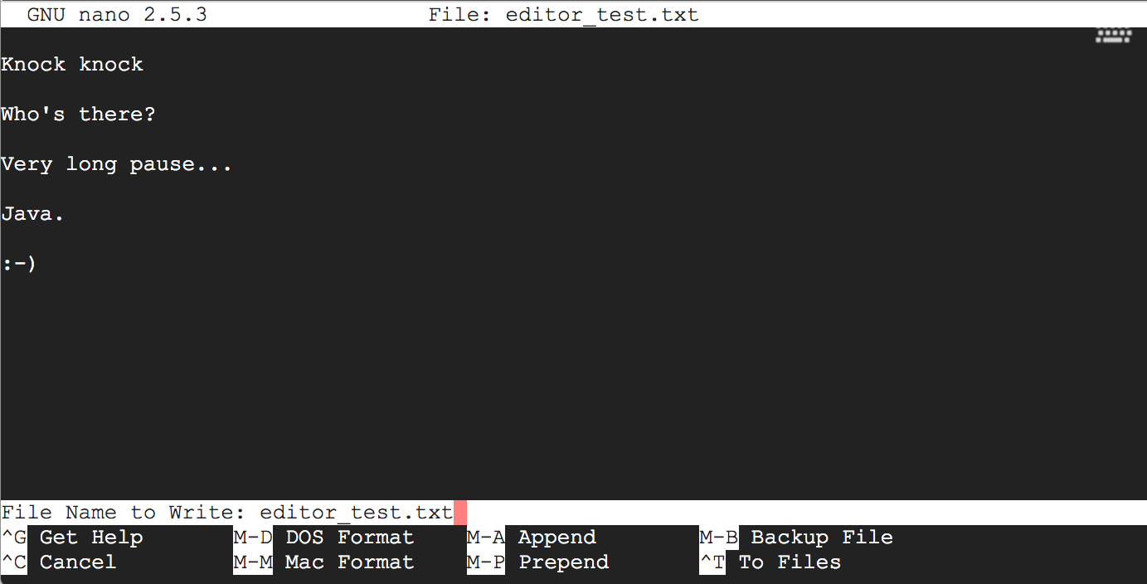

You'll need to confirm the file that you want to write the content to by hitting Enter. After this, exit the program by hitting Ctrl+X

CTRL-X



That's it! You've successfully created and modified a file.

## Conclusion

In this lab, we've gone through the basics of creating, modifying, copying, and removing files and folders in Linux. As always, you can learn more about each of the commands we've covered by using the man command. Make sure to practice these commands so that you get comfortable using them.